Red Ribbon Week
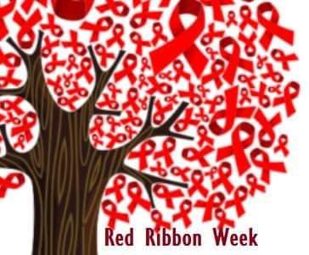
Oct 25th – Oct 28th

A Week Focusing on Making Safe & Healthy Choices

***There will be a few special surprises for students throughout Red Ribbon Week***

SPIRIT WEEK
Monday Oct 25th – “I am a Jean-ius” (for being Internet SAFE) wear jeans day
Virtual Assembly 10:45 am with ***Special Guests, Det. Eric Kjorness with Moscow PD and the Idaho Internet Crimes Against Children Task Forces and our own SRO, Officer Rob Massey to talk about internet safety, cyberbullying, and drug abuse prevention
Tuesday Oct 26th – “Sock it to Drugs” wear crazy/mismatched socks day
Wed Oct 27th – “Smarties Choose to be Kind & Drug Free” – hat day
Thurs Oct 28th – “I’m Red-y to Live Drug Free”- wear RED day
RED RIBBON DANCE PARTY during lunch recess

About Red Ribbon Week at Centennial Oct. 25th – Oct. 28th
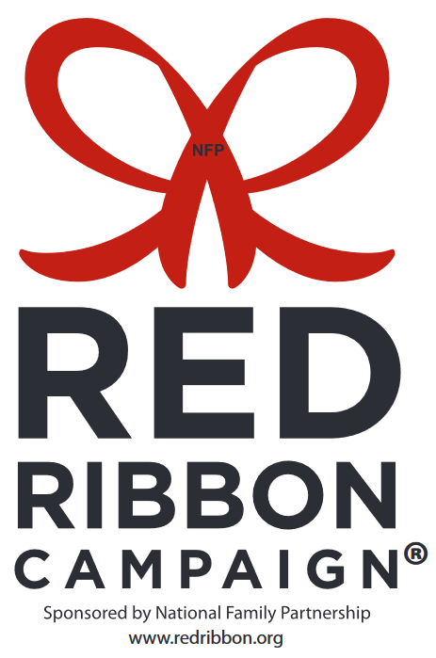
DID YOU KNOW?

Children of parents who talk to their kids regularly about drugs are 42% less likely to use drugs than those who don’t; yet, only a quarter of teens report having these conversations.

Red Ribbon®, the oldest and largest drug prevention campaign in the nation, is your opportunity to get the ongoing conversation started.
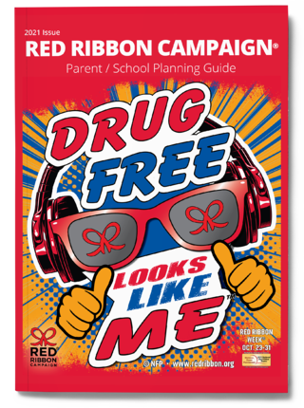
This year’s theme is Drug Free Looks Like Me. Visit www.redribbon.org to learn more about Red Ribbon Week® and get tips for talking to your kids about drugs. The life you save may be that of your own child or a dear friend.

Check out the Red Ribbon resources at the school counseling website: www.centennialramscounseling.weebly.com

