OCTOBER NEWSLETTER – CENTENNIAL SCHOOL COUNSELING PROGRAM
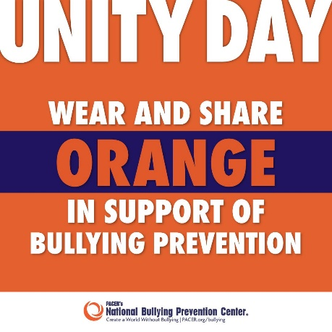
Brisk mornings, leaves turning golden…fall is officially here. There are a lot of things happening at Centennial this month! Our school will be participating in Unity Day on Wednesday, October 20 by wearing the color Orange. Wearing orange together is a way to show unity and stand up for others to prevent bullying at our school. The more empowered our students are, the less likely they are to be bullied. Plus, they will feel more confident about what to do when bullying happens. If you would like more information about bullying, check out the resources page on the school counseling website, www.centennialramscounseling.weebly.com or Pacer’s National Bullying Prevention Center at www.pacer.org/bullying .

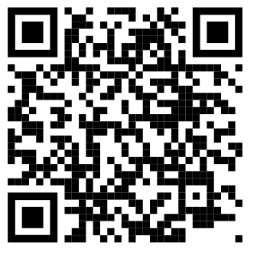
October 25-28 is also Red Ribbon Week – a national campaign to help kids be safe, healthy, and grow up drug free. This year’s theme is “Drug Free Looks Like me.” Youth use of e-cigarettes or vaping has been increasingly in the news, and 1 in 5 high school students have reported misusing prescription medications. Research shows that parents who talk to their children about avoiding drug use are much less likely to use drugs than those that don’t. Be on the lookout for a flyer describing events planned for Red Ribbon Spirit Week. Ask your student about the special guests during our virtual Red Ribbon Week Assembly to see what your child learned about making safe and healthy choices! There are also fun activities that students can do at home in Mrs. J’s Bitmoji Red Ribbon Classroom. There is a link to the Red Ribbon classroom on the student resources page on the counseling website, www.centennialramscounseling.weebly.com .

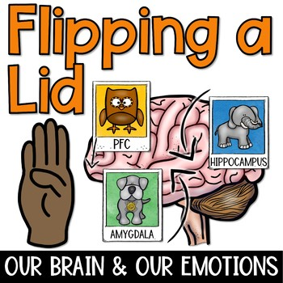
We are learning about our brains and the neurobiology behind the body’s stress response (also called “Fight, Flight or Freeze”) during our class lessons this first quarter of the school year. Your student should be able to tell you all about the roles that their Prefrontal Cortex (“Wise Owl”), hippocampus (“Elephant”), and amygdala (“Guard Dog”) play in their brains and what happens when big feelings take over (“Flipping your Lid”). Elementary students are learning about their brains to help them understand the process of self-regulation – managing emotions and behaviors. The ability to self-regulate helps children to problem solve, manage impulsive behaviors, self-soothe, and persevere when faced with something that isn’t easy. It is a vital skill for children to learn to be successful in school and throughout their entire lives. You can support this learning at home by talking with your student about different ways to cope with difficult feelings (“calming your guard dog”), and showing how you cope with difficult feelings. During counseling lessons, students and I will be practicing different mindfulness and relaxation strategies to build up their toolbox of coping skills. Ask your student to show you some of the activities and practice them together at home.

